JULY
 |  | 1 | 2 | 3 | 4 | 5
6 | 7 | 8 | 9 | 10 | 11 | 12
13 | 14 | 15 | 16 | 17 | 18 | 19
20 | 21 | 22 | 23 | 24 | 25 | 26
27 | 28 | 29 | 30 | 31
JANUARY
 |  |  |  | 1 | 2 | 3
4 | 5 | 6 | 7 | 8 | 9 | 10
11 | 12 | 13 | 14 | 15 | 16 | 17
18 | 19 | 20 | 21 | 22 | 23 | 24
25 | 26 | 27 | 28 | 29 | 30 | 31
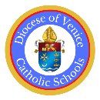
1 Solemnity of Mary
5 School back
5 Epiphany
8 Exec. Committee Zoom
15 All Principal Zoom
19 MLK Jr. Day
26-30 Catholic Schools Week
19 Teacher 19 student

2 DOV STREAM Symposium
6All Principal Meeting
12 TYPA St Andrew
13 TYPA St. Martha
19 Solemnity of St. Joseph
19 School Board President Meeting
19 MS Robotic Ref Training
20 HS Robotic Ref Training
29 Palm Sunday
17 Teacher 16 student

5-6Colloquio (All Principal Retreat)
16 Presidents Day
18 Ash Wednesday
26 DOV School board meeting

19 Teacher 19 student

31 New Hire Orientation

1 Teachers setting up rooms
4 Teachers Officially Back
6 Teacher Mass PD day
11First Day of School
15Assumption Virgin Mary
21-22 All Principal Workshop

21 Teacher 15 student

AUGUST
 |  |  |  |  | 1 | 2
3 | 4 | 5 | 6 | 7 | 8 | 9
10 | 11 | 12 | 13 | 14 | 15 | 16
17 | 18 | 19 | 20 | 21 | 22 | 23
24  31 | 25 | 26 | 27 | 28 | 29 | 30
FEBRUARY
1 | 2 | 3 | 4 | 5 | 6 | 7
8 | 9 | 10 | 11 | 12 | 13 | 14
15 | 16 | 17 | 18 | 19 | 20 | 21
22 | 23 | 24 | 25 | 26 | 27 | 28

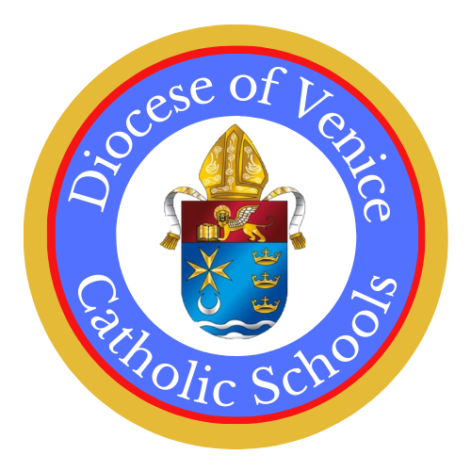

SEPTEMBER
 | 1 | 2 | 3 | 4 | 5 | 6
7 | 8 | 9 | 10 | 11 | 12 | 13
14 | 15 | 16 | 17 | 18 | 19 | 20
21 | 22 | 23 | 24 | 25 | 26 | 27
28 | 29 | 30
MARCH
1 | 2 | 3 | 4 | 5 | 6 | 7
8 | 9 | 10 | 11 | 12 | 13 | 14
15 | 16 | 17 | 18 | 19 | 20 | 21
22 | 23 | 24 | 25 | 26 | 27 | 28
29 | 30 | 31
1 Labor Day
8 Feast of the Nativ. of Mary
14 Feast of the Exaltation of the Holy Cross
18 Principal Zoom (K8/HS)
25 DOV School Board Meetin
21 Teacher 21 student

OCTOBER
 |  |  | 1 | 2 | 3 | 4
5 | 6 | 7 | 8 | 9 | 10 | 11
12 | 13 | 14 | 15 | 16 | 17 | 18
19 | 20 | 21 | 22 | 23 | 24 | 25
26 | 27 | 28 | 29 | 30 | 31

1 Visit St Catherine
2 Visit St Andrew
7 Mem. of Our Lady of the Rosary
7 Visit St. Francis Xavier
9 Atlas Teacher Zoom Training
13 Columbus Day
14 Visit St Charles Borromeo
15 Atlas Teacher Zoom Training REPEAT
17 Devotional Project Training
23All School Board Members
24 Admissions Directors Meeting
with School Board Pres.meeting (After)
28 Visit Mooney
31 Visit Donahue Academy
23 Teacher 23 student

2-6 Easter Break
17 Art Competition Deadline
18 LION CUP V
24 Devotional Art winners Announced
29 DOV School Board Meeting

19 Teacher 19 student

APRIL
 |  |  | 1 | 2 | 3 | 4
5 | 6 | 7 | 8 | 9 | 10 | 11
12 | 13 | 14 | 15 | 16 | 17 | 18
19 | 20 | 21 | 22 | 23 | 24 | 25
26 | 27 | 28 | 29 | 30

MAY
 |  |  |  |  | 1 | 2
3 | 4 | 5 | 6 | 7 | 8 | 9
10 | 11 | 12 | 13 | 14 | 15 | 16
17 | 18 | 19 | 20 | 21 | 22 | 23
24  31 | 25 | 26 | 27 | 28 | 29 | 30
1 St.Joseph the Worker
4-8 ARK Testing Window
11 Devotional Project Mass
11 Nennolina Novena (to 5/16)
14All Principal Zoom
21Ascension of the Lord
24 Pentecost
25 Memorial Day
29 Last Day Students
20 Teacher 20 student

NOVEMBER
 |  |  |  |  |  | 1
2 | 3 | 4 | 5 | 6 | 7 | 8
9 | 10 | 11 | 12 | 13 | 14 | 15
16 | 17 | 18 | 19 | 20 | 21 | 22
23  30 | 24 | 25 | 26 | 27 | 28 | 29
1 All Saints Day
2 All Souls Day
5 Visit St. John Neumann (TYPA)
6 All Principal Meeting
7 Visit St Ann
11 Veterans Day
17 Bishop Verot Visit
18 Visit Seton
24-30 Thanksgiving Break
30 First Sunday of Advent

14 Teacher 14 student

JUNE
 | 1 | 2 | 3 | 4 | 5 | 6
7 | 8 | 9 | 10 | 11 | 12 | 13
14 | 15 | 16 | 17 | 18 | 19 | 20
21 | 22 | 23 | 24 | 25 | 26 | 27
28 | 29 | 30

2 Last Day Teachers
5 Principal Luncheon Party
3 Teacher 0 student

97 Teacher 93 student
190 Teacher 178 student (once 2 PD days added by schools)

DECEMBER
 | 1 | 2 | 3 | 4 | 5 | 6
7 | 8 | 9 | 10 | 11 | 12 | 13
14 | 15 | 16 | 17 | 18 | 19 | 20
21 | 22 | 23 | 24 | 25 | 26 | 27
28 | 29 | 30 | 31
8 Immaculate Conception
12 Principal Christmas
12 Feast of Our Lady of Guadalupe
17 DOV School Board Meeting
22 Christmas Break to 1/5
25 Christmas
14 Teacher 14 student
93 teacher 87 students

